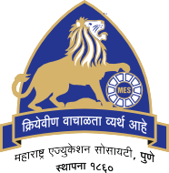

MAHARASHTRA EDUCATION SOCIETY'S
(SINCE 1860)
INSTITUTE OF MANAGEMENT & CAREER COURSES (IMCC)
(AUTONOMOUS)
Approved by AICTE and Recognized by Savitribai Phule Pune University, Pune
IMCC Campus, 131, Mayur Colony, Kothrud, Pune 411038, Maharashtra, India | Ph.: 020-2546 6271 / 73 | e-mail: info.imcc@mespune.in | https://imcc.mespune.in
NAAC Accredited with Grade A+
Ref. No. MES IMCC /442/2025-26 Date:09/05/2026

CERTIFICATE
This is to certify that the Project Report entitled

“Getmarket”
is prepared by

Ajinkya Anand Thakur

M.C.A. Semester IV Course for the Academic Year 2025-26 at M.E. Society's Institute of Management & Career Courses (IMCC), Pune - 411038. M.C.A Course is autonomous and afﬁliated to Savitribai Phule Pune University.

To the best of our knowledge, this is an original study done by the said student and important sources used by him/her have been duly acknowledged in this report.

The report is submitted in partial fulﬁllment of M.C.A Course for the Academic Year 2025-26 as per the rules and prescribed guidelines of Savitribai Phule Pune University.

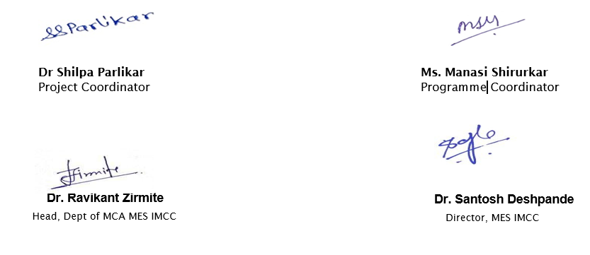

External Examiner

Head Ofﬁce: 'MES Bhavan', 1214-1215, Sadashiv Peth, Pune - 411030, Maharashtra, India. | Ph.: +91-020-41038100 | www.mespune.in

